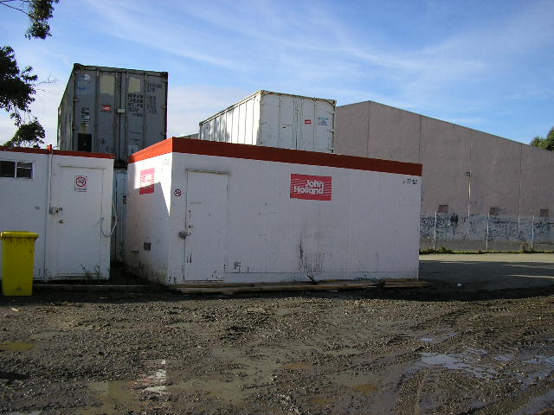 | Hazard Information Sheet
  Equipment: | Mobile Shed
 | Equip Type: | Mobile Shed
 | Generic Description or  Specific Make / Model: | Mobile Shed
 | Type: | Bottom Lift
 | Other Details

Operator Requirements: | Operators must be trained and competent to use this equipment safely.
Purpose For Which This Equip Is Designed: | Mobile shed used as office or base on site

Hazards & Risks:
Control Measures:
Crushing (Squashing):  Mobile shed may fall when being lifted into place crushing persons underneath | (i) When commissioning mobile sheds always ensure that 2 dogmen assist in the operation  (ii) Barricade off work areas - always keep clear work area of 6 metres surrounding shed  (iii) Operator training and awareness
Striking (Hitting):  Operators and bystanders may be struck when shed is being lifted into place | (i) Operator training and awareness.  (ii) When commissioning mobile sheds always ensure that 2 dogmen assist in the operation  (iii) Barricade off work areas - always keep clear work area of 6 metres surrounding shed
Falling:  Operators and bystanders may fall from a height when commissioning shed esp. top lift sheds | (i) Operator training and awareness.  (ii) When commissioning a top lift shed persons working at height to work in secure harness and lanyard equipment and always assisted by 2 dogmen  (iii) Barricade off work areas - always keep clear work area of 6 metres surrounding shed  (iv) All top lift sheds should be converted to bottom lift sheds

Disclaimer: In fulfilment of its statutory obligations, (ARS) & John Holland has taken what it considers to be all reasonable precautions and exercised due diligence to ensure that it has provided all relevant information on the safe use of the plant. However, except as required by law and only to the extent so required, (ARS) & John Holland does not make any representation, warranty or undertaking, express or implied, as to, or accept any responsibility or liability for, the accuracy or completeness of, or any errors in or omissions from, this Hazard Information Sheet. Except as required by law and only to the extent so required, neither (ARS) & John Holland nor any of its respective directors, officers, agents, or employees shall in any way be liable directly or indirectly to any person or body for any loss or damages, costs or expenses whatever arising out of or in connection with the information contained in this Hazard Information Sheet. | Date: 19/06/06
Equipment: | Mobile Shed  Bottom Lift

Hazards & Risks: | Control Measures:
Rupturing of services:  When decommissioning mobile shed services can be ruptured causing live wires, gas and water leaking and explosion | Ensure all services to mobile shed have been 'shut off' prior to moving shed in any way.

Disclaimer: In fulfilment of its statutory obligations, (ARS) & John Holland has taken what it considers to be all reasonable precautions and exercised due diligence to ensure that it has provided all relevant information on the safe use of the plant. However, except as required by law and only to the extent so required, (ARS) & John Holland does not make any representation, warranty or undertaking, express or implied, as to, or accept any responsibility or liability for, the accuracy or completeness of, or any errors in or omissions from, this Hazard Information Sheet. Except as required by law and only to the extent so required, neither (ARS) & John Holland nor any of its respective directors, officers, agents, or employees shall in any way be liable directly or indirectly to any person or body for any loss or damages, costs or expenses whatever arising out of or in connection with the information contained in this Hazard Information Sheet. | Date: 19/06/06

